Getting Started with Simulink CIGRE Build Process

This guide will help you set up and configure the CIGRE build process in Simulink. Follow these steps to get started.

Prerequisites
- Toolchain
  - Visual Studio for C compiler
    - 2017
    - 2019
    - 2022
  - MinGW
- MATLAB/Simulink ver. R2020a or later
  - Simulink Coder
  - Embedded Coder
- CIGRE mltbx

Toolchain Setup

Visual Studio
Install a supported version of Visual Studio, along with C/C++ toolchains.

MinGW
If not already set up, install MinGW support package through MATLAB:
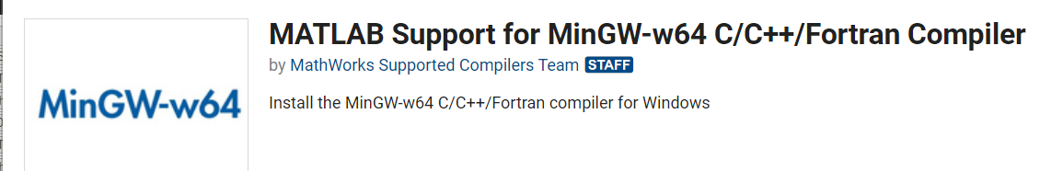
You may need to restart MATLAB.
Run
compilers = mex.getCompilerConfigurations('C', 'Installed');
minGW = compilers(ismember({compilers(:).Name}', 'MinGW64 Compiler (C)'))
Add the path specified for the LinkerName to the path:
Open System Environment Variables:

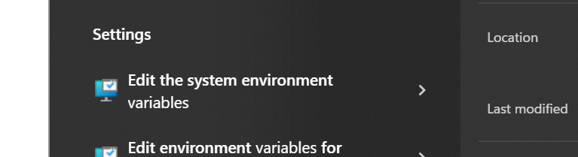
Go to “Advanced -> Environment Variables”
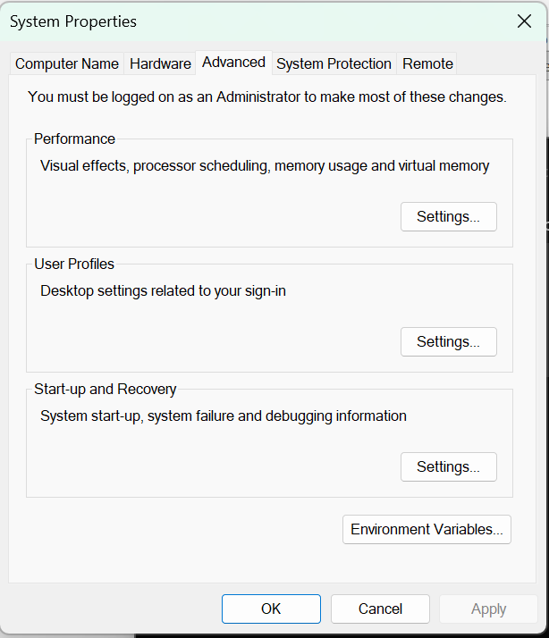
Add the path, e.g. “C:\ProgramData\MATLAB\SupportPackages\R2023b\3P.instrset\mingw_w64.instrset\bin\” to the path”.
Restart MATLAB.
In MATLAB, run
!gcc
If you get the following error, it should be configured correctly:
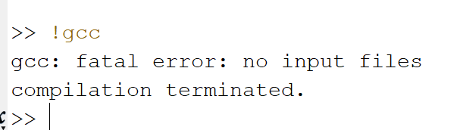

Installation
- Install the CIGRE toolbox by running CIGRE.mltbx inside your MATLAB environment.
- Create the required CIGRE DLL toolchains by running:
cigre.install(“VSVersion”, <<version>>)
where <<version>> matches an installed version of Visual Studio.
This will create both 32- and 64-bit CIGRE DLL toolchains and register them with Simulink.
- Check the installation of the model advisor checks by:
cigre.test.advisorChecks

Model Configuration
- Open the model configuration.
- Navigate to Hardware Target and choose whether you want to generate a 32- or 64-bit DLL.
- Navigate to Code Generation and set the System target file to ‘cigre.tlc’
- Select the appropriate CIGRE DLL toolchain

Model Checker
To check if a model is compatible with the CIGRE DLL code generation run checks on the model.
cigre.checkModel(<<modelName>>)
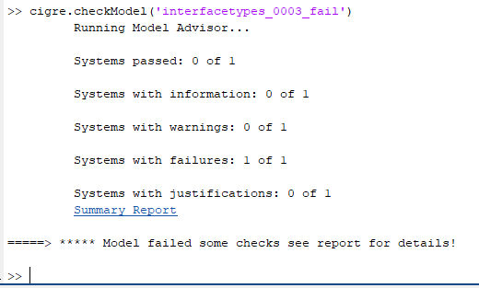
For details press the Summary Report link.
To run the model advisor interactively, open the model advisor from the modelling pane.
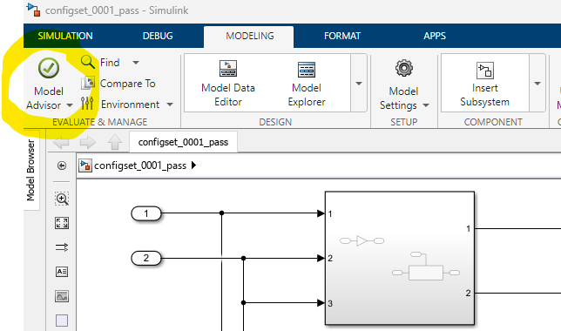

Select the CIGRE checks under the By Product folder:
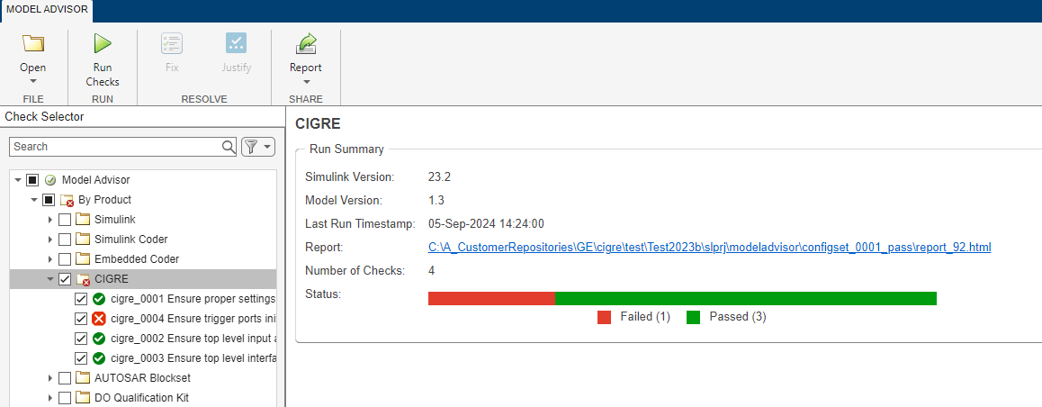

And run them.

Building the Model
- The model is build by calling
cigre.buildDLL(<<modelName>>)
where <<modelName>> is the name of the top level model that you wish to build. This will create a DLL called <<modelName>>_CIGRE.dll, along with a header <<modelName>>_CIGRE.h that describes the DLL interface.

Known Limitation
- The top-level model cannot contain virtual buses.
- Logical/Boolean data in Simulink is converted to int32 in CIGRE.
- Compatibility mode for triggered subsystem initialisation is not supported due to how the initialisation code is generated: 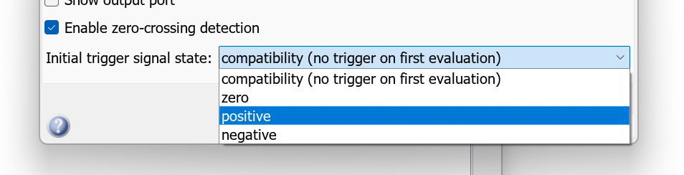
- (u)int64 is not generally supported as this requires support for multi-word typedefs
- Must use fixed time-step
- Model must have at least one input

